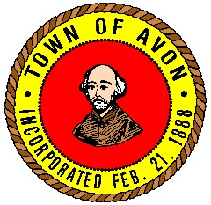
Avon Park and Recreation Commission
65 East Main Street, Avon, MA 02322
Barbara Littlefield Chairperson | Carl Fischer Vice Chairperson
Michael Lawler Commissioner | Stephen McCarthy Commissioner
Dan Hart Commissioner | Carol Geary Secretary

HELP WANTED
COUNSELORS FOR WINTER TEEN PROGRAM

December 11, 2017
Job Posting Avon Park and Recreation are looking for two individuals to help run the Winter Teen Program for the Park and Recreation Commission.
- This person must be out going and able to connect with children to keep them socially engaged with the activities and field trips associated with the Winter Teen Program.
- Be able to follow directions as well as be able to handle any issues that arise.
- Follow the directions of the Winter Teen Program Director and interact with parents.
Salary: 10.26 per hour
This is a seasonal employment no benefits
All interested candidates please complete an employment application and forward to:
Shanna Faro Human Resources Coordinator
Town of Avon
65 East Main Street
Avon, MA 02322
E-mail: sfaro@avon-ma.gov
Review of applications will begin on December 29, 2017. This posting is open until the position are filled
The Town of Avon is an ADA/Equal Employment Opportunity/Affirmative Action Employer.

