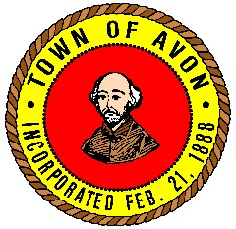
Avon Park and Recreation Commission
65 East Main Street, Avon, MA 02322
Benjamin Chapman, Chairman | Jocelyn Lyons, Vice Chair
Lori Fischer, Commissioner | Matthew Ferro, Commissioner
Daniel Hart, Commissioner | Matthew McAndrew, Recreation Director

JOB POSTING
Summer Program Playground Supervisor
Grade G3, Steps 1-3

The Town of Avon is seeking qualified applicants to fill the position of Playground Supervisor for the Park & Recreation’s Summer Program. The Playground Supervisor provides routine to complex administrative, supervisory, clerical and record keeping work related to the Summer Program and works under the direct supervision of the Program Director.
Duties include but are not limited to: assist the Program Director to interview new candidates for position of counselor; assist the Program Director with orientation for the counselors; meet with the Program Director regularly to keep informed of all details of the program; keep thorough and detailed records of any injury/behavior/discipline incidents and report to Program Director; recognize and respond effectively to any emergencies; serve as a liaison between parents, staff and Program Director; oversee the playground program; meet weekly with Counselors about planned activities; create list of children attending field trips, assign groups to counselors; and organize clinics, activities and crafts so they appeal to the variety of ages and children.
Candidates must have a minimum of two years in higher education with major in field of education preferred. Must have over two years of recreational program experience. The Summer Program will run from July 5, 2023 through August 11, 2023. The work week is Monday through Friday from 7:30 a.m. to 2:30 p.m. with some late afternoon and evening hours required. This is a seasonal position with no benefits. The salary range is $16.49 to $17.32 based on experience. Full job description available upon request. Send Employment Application to Shanna Faro, Human Resources Coordinator, 65 East Main Street, Avon, MA 02322 or e-mail at humanresources@avon-ma.gov. Review of applications will begin on May 10, 2023. EOE.

