MATTRESSES, BOX SPRINGS & FUTONS | - Dispose at the curb on Bulk Collection Day for a fee of $10.00 per mattress and $15.00 per box spring. Request a ticket at the Clerk’s Office at Town Hall prior to Bulk Collection Day.  - Residents may also find more information at Massachusetts Department of Environmental Protection Website.
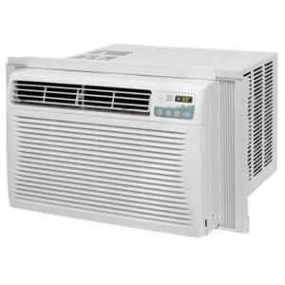  A/C UNITS | - Dispose for free on Bulk Collection Day or for $15 each at the Compost Site. Request a ticket at the Clerk’s Office prior to disposing at the Compost Site.
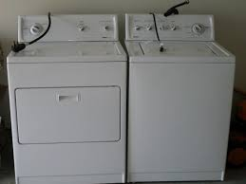  WASHERS & DRYERS, HUMIDIFIERS | - Dispose for free on Bulk Collection Day (must contact Howland Disposal prior to Bulk Collection Day – see phone number below) or you may dispose these for a fee of $15 each at the Compost Site. Request a ticket at the Clerk’s Office prior to disposing at the Compost Site.
STEREOS, PRINTERS, SCANNERS, COPIERS, FAX MACHINES, KEYBOARDS, MOUSE, VIDEO GAMES, INK JET CARTRIDGES, SPACE HEATERS, CHRISTMAS LIGHTS, TOASTERS, VCR’S & DVD’S AND WIRES AND CABLES | - Dispose for free at the Compost Site.
 | - The following items are acceptable for composting at the Compost Site: Brush less than 2” in diameter, Grass Clippings & Leaves. Please no bags.

THE NEXT BULK COLLECTION DAY IS SATURDAY, AUGUST 12TH.
COMPOST SITE, 100 WALES AVENUE – HOURS WED, SAT, SUN 9 A.M. – 2 P.M.
Your vehicle must be registered in Avon. No Commercial vehicles.
HOWLAND DISPOSAL 1-877-667-9600 OR 508-746-9600

THE COMPOST SITE OPENS IN THE SPRING AND CLOSES IN NOVEMBER

