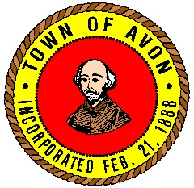
Avon Park and Recreation Commission
65 East Main Street, Avon, MA 02322
Barbara Littlefield Vice Chairperson | Carl Fischer Chairperson
Ben Chapman Commissioner | Stephen McCarthy Commissioner
Dan Hart Commissioner | Carol Geary Secretary

4/3/2018

Job Posting Avon Park and Recreation are looking for 6 individuals to help run the Summer Program for the Park and Recreation Commission.

•This person must be out going and able to connect with children to keep them socially engaged with the activities and field trips associated with the Summer Program.
• Be able to follow directions as well as be able to handle any issues that arise.
• Follow the directions of the Youth Program Director and interact with parents.

This is a seasonal employment no benefits All interested candidates please complete an employment application and forward to:
Shanna Faro Human
Resources Coordinator
Town of Avon
65 East Main Street
Avon, MA 02322

Review of applications will begin on April 30, 2018. This posting is open until the position are filled The

Town of Avon is an ADA/Equal Employment Opportunity/Affirmative Action Employer.

