TOWN OF AVON BOARD OF HEALTH A PUBLIC HEARING

Town of Avon

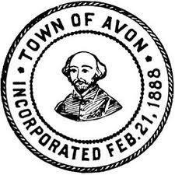

Board of Health

Notice is hereby given pursuant to M.G.L. c 30A, §2, that the Avon Board of Health will hold a public hearing in the Mary T. McDermott Meeting Room located at the Town Hall, 65 East Main Street, Avon MA on Thursday April 13, 2017, at 6:00 PM. This hearing is in regards to adopting the “Regulation of the Avon Board of Health restricting the Sale of Tobacco Products”. The regulation includes but is not limited to, amending the definition of tobacco and increasing the minimum legal sales age to purchase tobacco products to 21. A copy of the proposed regulation can be viewed at the Board of Health office.

Gerald Picardi, Chairman
Board of Health

