To: Patricia Bessette, Town Clerk
From: Mary Ann Diamond
Date: 1/2/2018

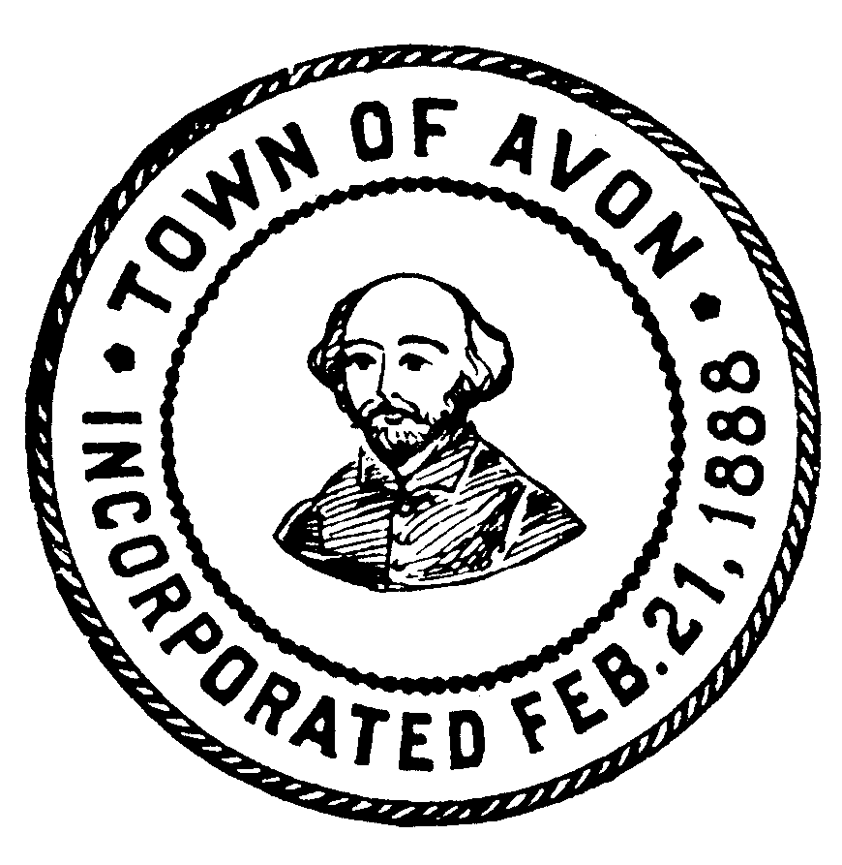

POSTED IN ACCORDANCE WITH THE PROVISIONS OF MGL 30A S18-25
PLANNING BOARD

Thursday, January 04, 2018 | 7:00 PM
PLANNING BOARD OFFICE | SUBJECTS TO BE DISCUSSED BELOW

Approve Minutes of previous meeting(s): | 12/7, 12/14/17 & past minutes to date
Old Business: | Warrants – Jacobs Driscoll : Peer Reviews for 430 Page Street, ABC Supply, 190 Central St.
New Business: | 7:30 P.M. – Continued Public Hearing 190-200 Central Street
Other: | Review applications, bills received, letters, notices, and other correspondence received  Public Questions
Meeting Posted by: Mary Ann Diamond

